Numl university Hyderabad



ASSIGNMENT #1

**Submitted by :- Khadija Abbasi**

**Class :- BSCS-III**

**Subject :- Digital Logic Design**

**Submitted to :- Sir Rafay**

**Date :- 7-Mar-2023**

**Session :- 2023**

PRACTICAL # 1:

Q:1 Which gates are categorized as universal gates and how they are used?

Ans:

A universal gate is a gate which can implement any Boolean function without need to use any other gate type.

There are two category of Universal Gate.

1. NAND Gate.
2. NOR Gate.

Q:2. Verify the Truth Table for AND Gate and OR Gate.

**AND GATE:**

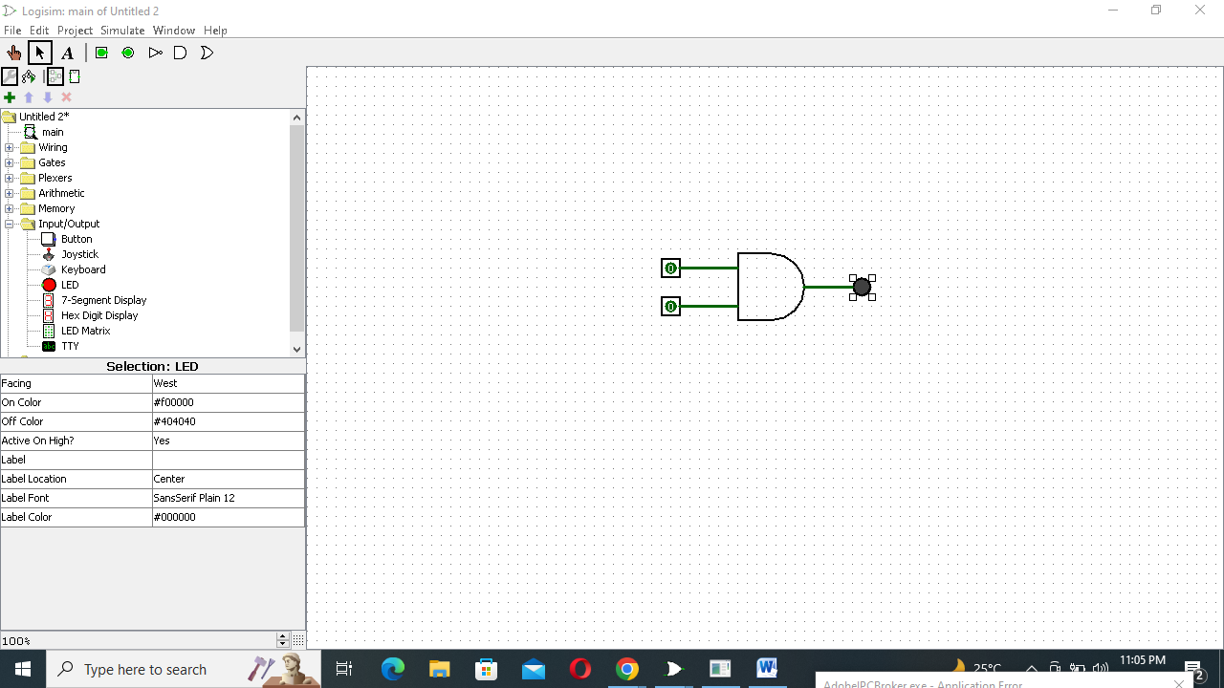 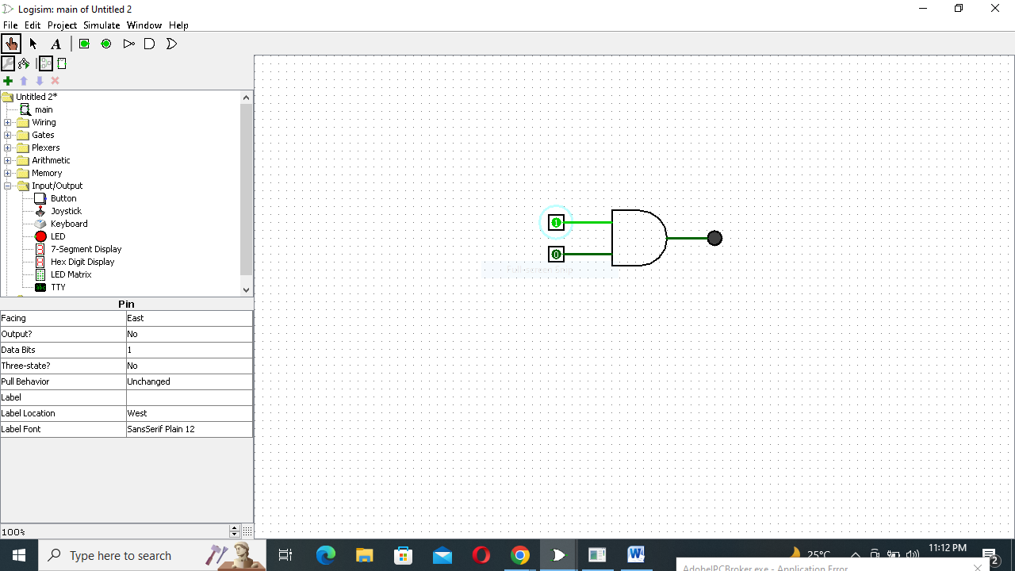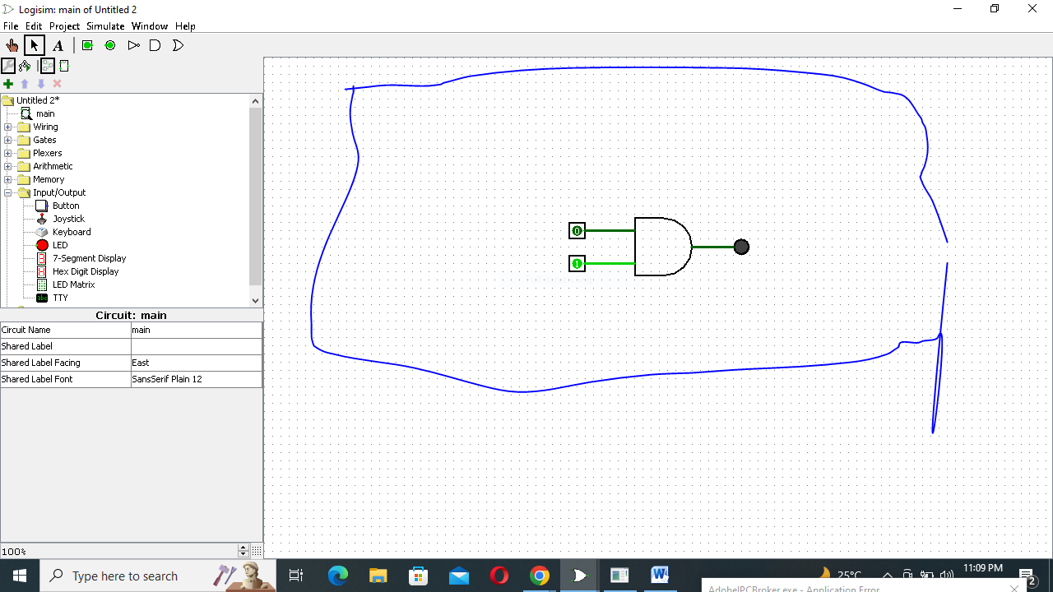

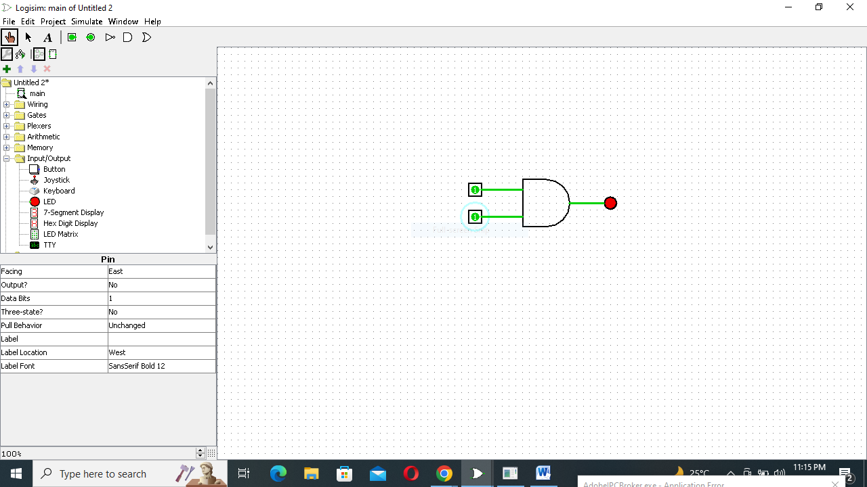

Truth Table:

|  |  |  |
| --- | --- | --- |
| A | B | O |
| 0 | 0 | 0 |
| 0 | 1 | 0 |
| 1 | 0 | 0 |
| 1 | 1 | 1 |

**OR GATE:**

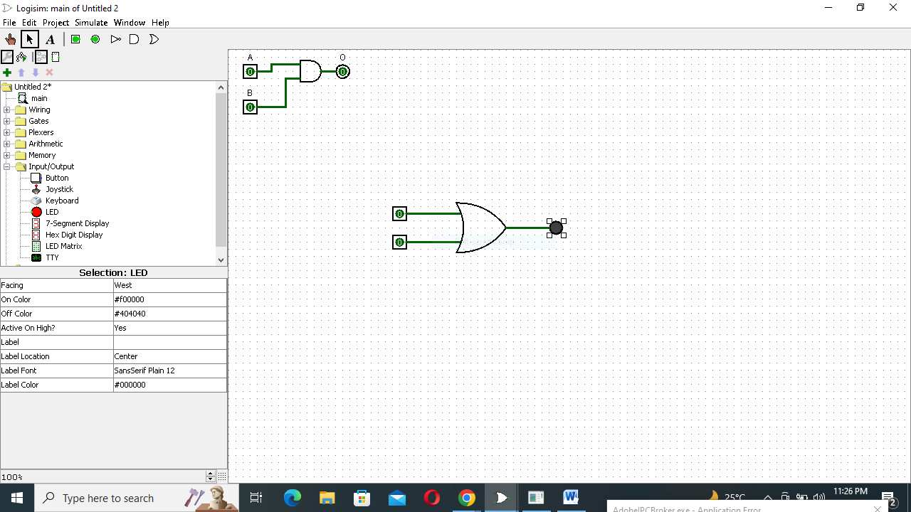 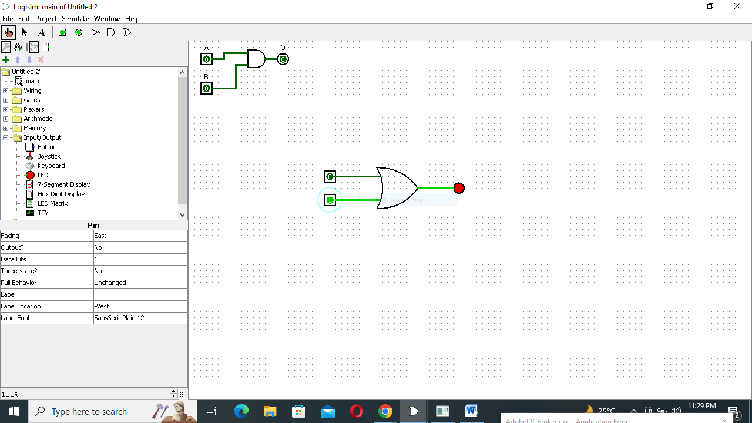

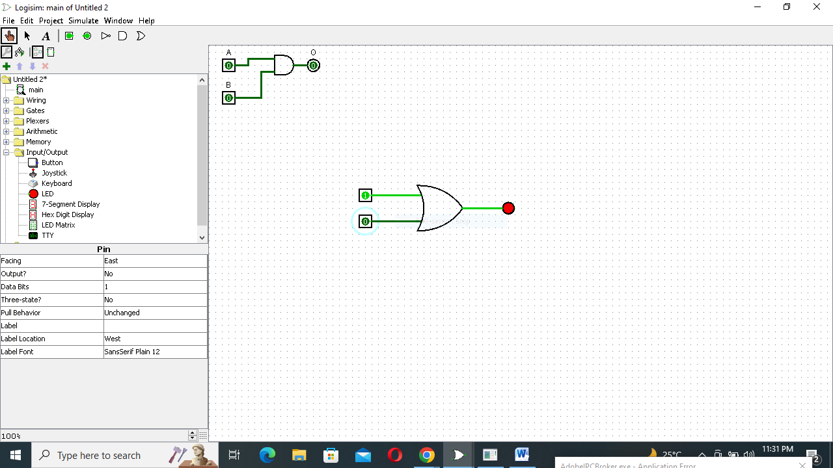 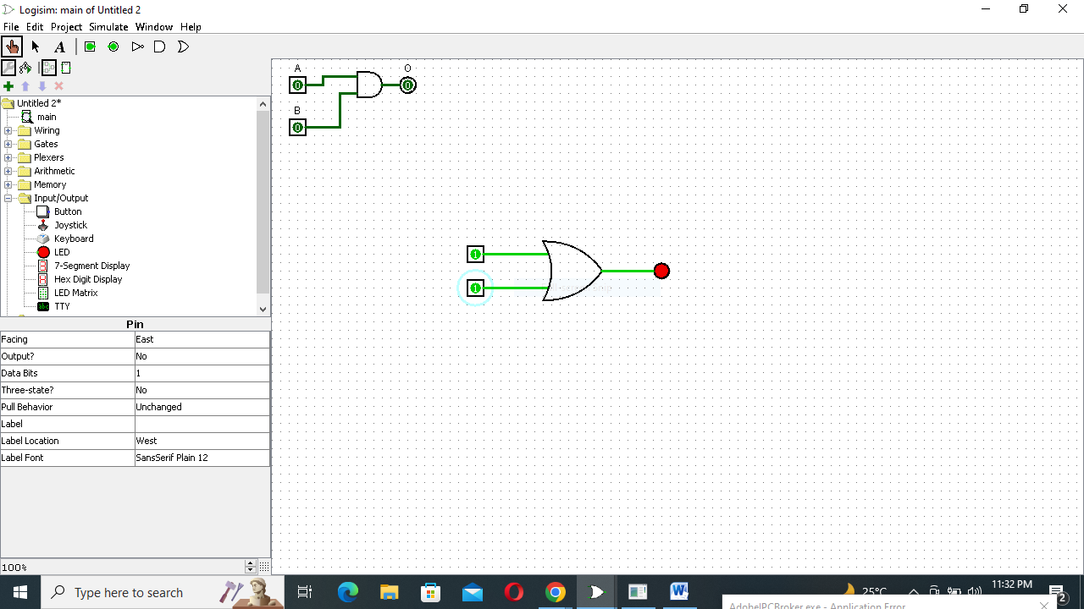

Truth Table:

|  |  |  |
| --- | --- | --- |
| A | B | O |
| 0 | 0 | 0 |
| 0 | 1 | 1 |
| 1 | 0 | 1 |
| 1 | 1 | 1 |

Q:3 Verify the Truth Table for NOR Gate and NAND Gate.

**NOR GATE:**

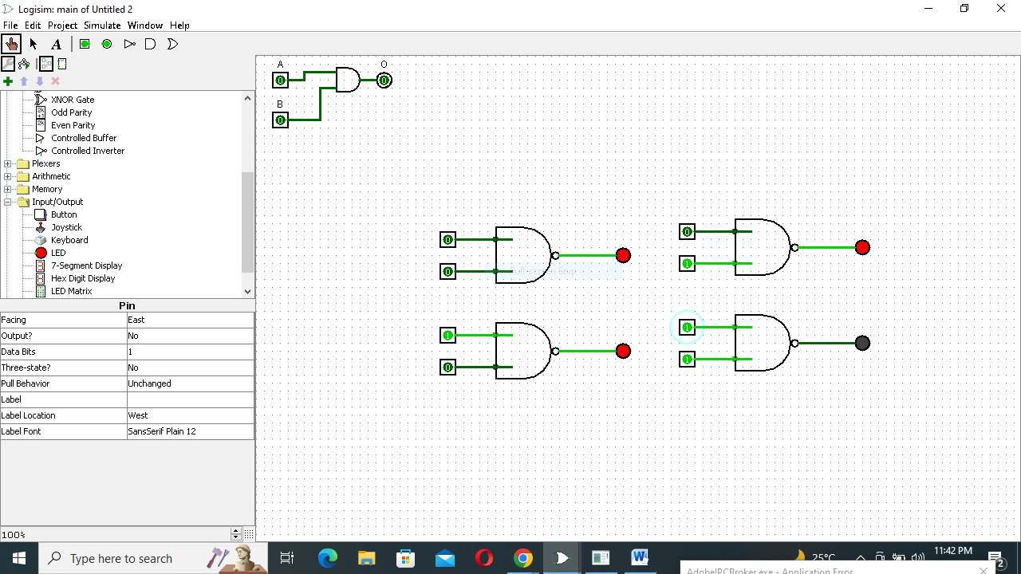

Truth Table:

|  |  |  |
| --- | --- | --- |
| A | B | O |
| 0 | 0 | 1 |
| 0 | 1 | 1 |
| 1 | 0 | 1 |
| 1 | 1 | 0 |

**NOR GATE:**

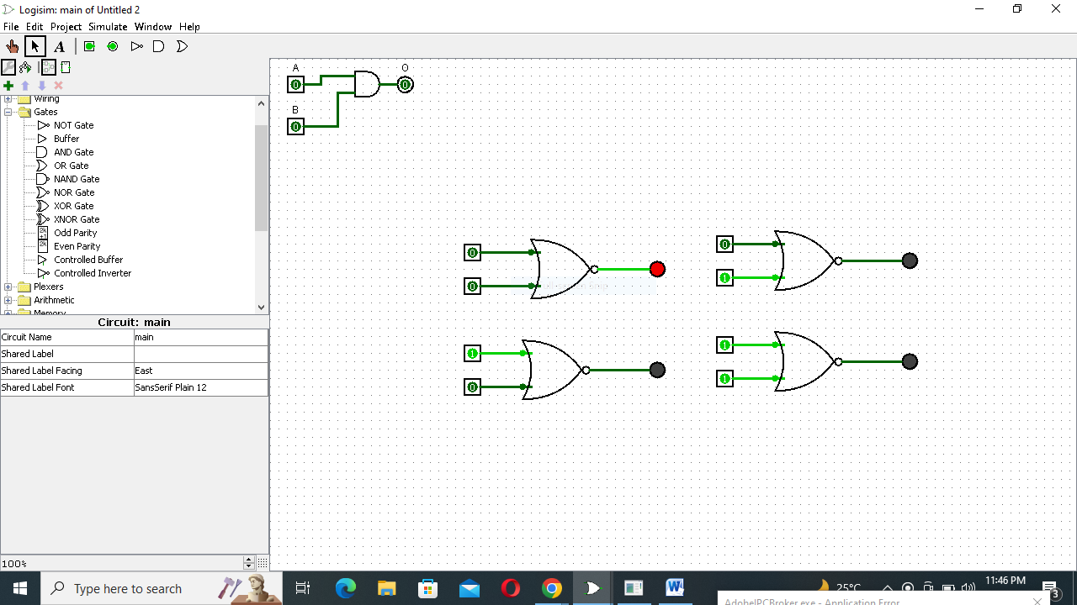

Truth Table:

|  |  |  |
| --- | --- | --- |
| A | B | O |
| 0 | 0 | 1 |
| 0 | 1 | 0 |
| 1 | 0 | 0 |
| 1 | 1 | 0 |

Q:4 Verify the Truth Table for XOR Gate and XNOR Gate.

**XOR GATE:**

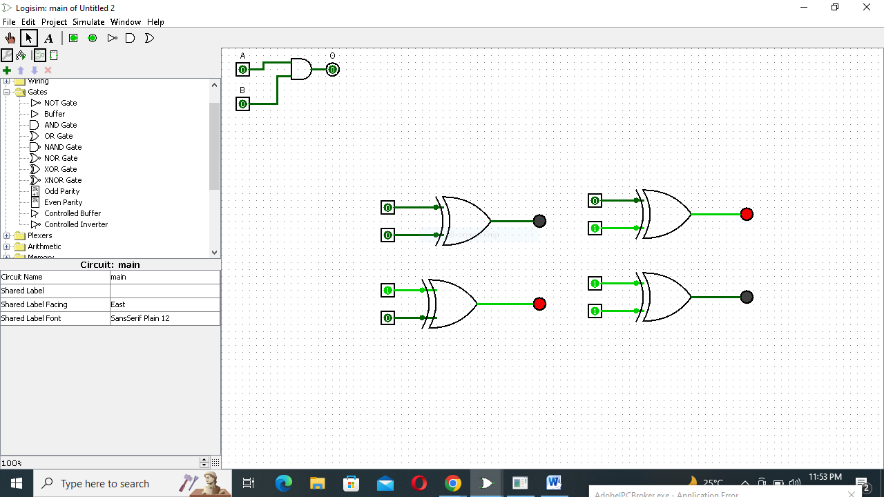

Truth Table:

|  |  |  |
| --- | --- | --- |
| A | B | O |
| 0 | 0 | 0 |
| 0 | 1 | 1 |
| 1 | 0 | 1 |
| 1 | 1 | 0 |

**XNOR GATE:**

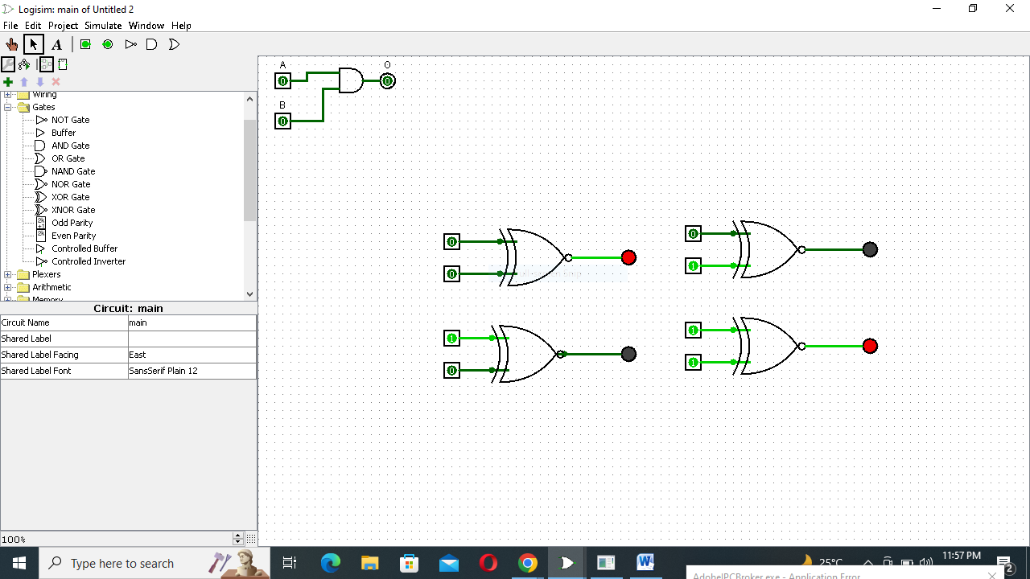

Truth Table:

|  |  |  |
| --- | --- | --- |
| A | B | O |
| 0 | 0 | 1 |
| 0 | 1 | 0 |
| 1 | 0 | 0 |
| 1 | 1 | 1 |

Q:5 Convert the following logic gate circuit into a Boolean expression, writing Boolean sub-expressions next to each gate output in the diagram:

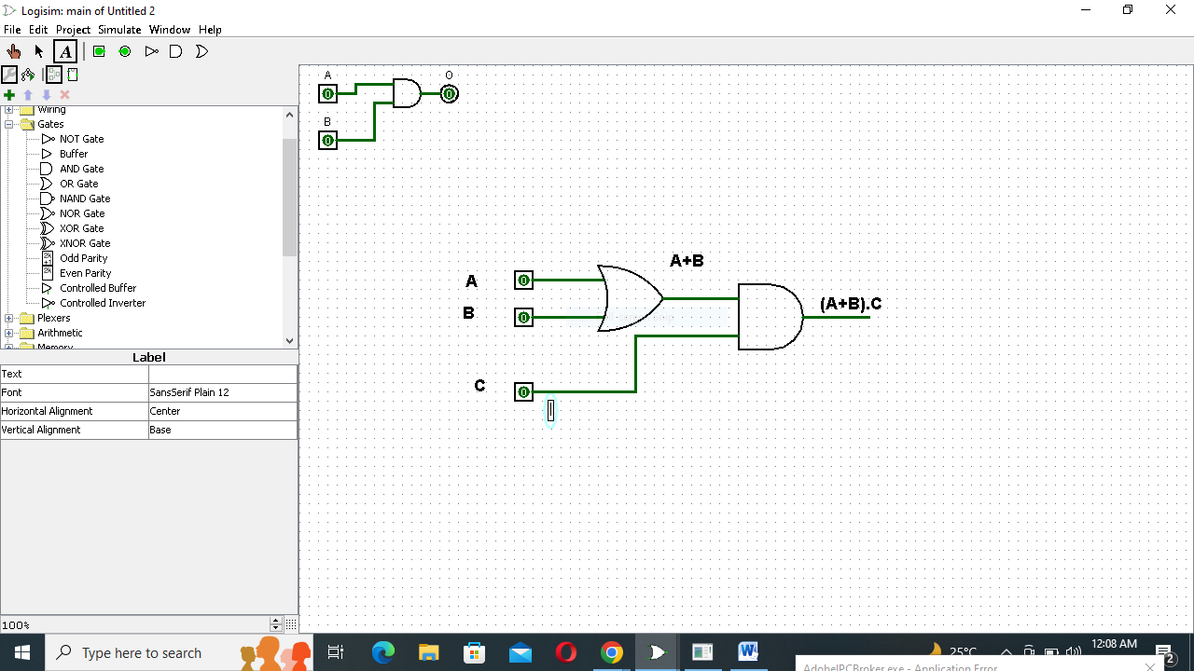

Q:6. Draw the following function in Circuit maker.

1. **F = 𝑿̅’YZ + 𝑿̅’Y𝒁̅’ + XZ**

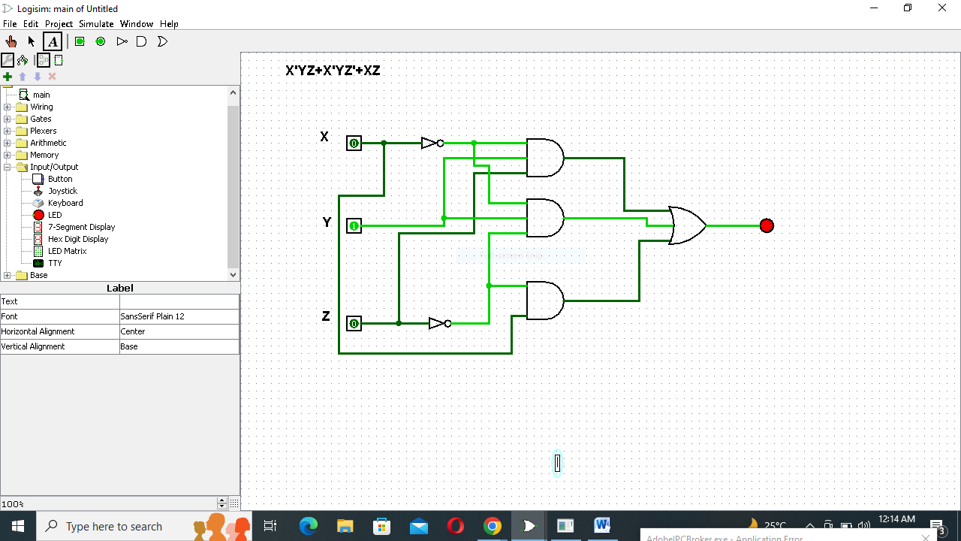

**Truth Table:**

|  |  |  |  |  |  |  |  |  |  |
| --- | --- | --- | --- | --- | --- | --- | --- | --- | --- |
| **X** | **Y** | **Z** | **X’** | **Y’** | **Z’** | **X’YZ** | **X’YZ’** | **XZ** | **X’YZ+X’YZ’+XZ** |
| **0** | **0** | **0** | **1** | **1** | **1** | **0** | **0** | **0** | **0** |
| **0** | **0** | **1** | **1** | **1** | **0** | **0** | **0** | **0** | **0** |
| **0** | **1** | **0** | **1** | **0** | **1** | **0** | **1** | **0** | **1** |
| **0** | **1** | **1** | **1** | **0** | **0** | **1** | **0** | **0** | **1** |
| **1** | **0** | **0** | **0** | **1** | **1** | **0** | **0** | **0** | **0** |
| **1** | **0** | **1** | **0** | **1** | **0** | **0** | **0** | **1** | **1** |
| **1** | **1** | **0** | **0** | **0** | **1** | **0** | **0** | **0** | **0** |
| **1** | **1** | **1** | **0** | **0** | **0** | **0** | **0** | **1** | **1** |

**F=𝑿̅’Z + X𝒀̅’Z +Y𝒁̅’**

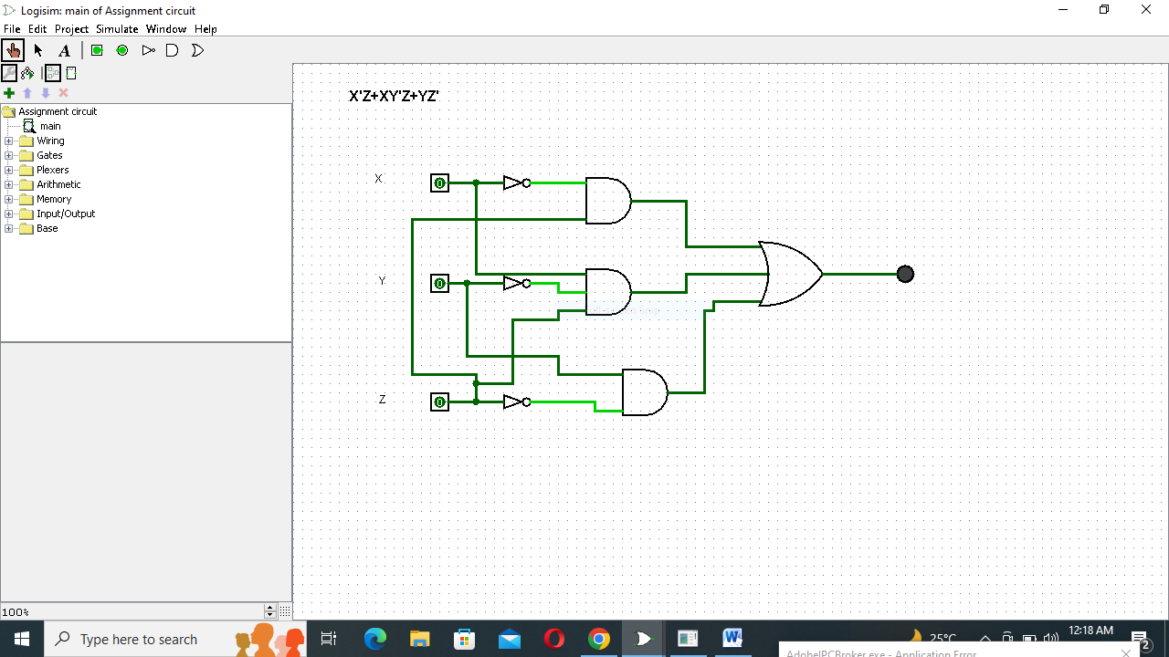

**Truth Table:**

|  |  |  |  |  |  |  |  |  |  |
| --- | --- | --- | --- | --- | --- | --- | --- | --- | --- |
| **X** | **Y** | **Z** | **X’** | **Y’** | **Z’** | **X’Z** | **XY’Z** | **YZ’** | **X’Z+XY’Z+YZ’** |
| **0** | **0** | **0** | **1** | **1** | **1** | **0** | **0** | **0** | **0** |
| **0** | **0** | **1** | **1** | **1** | **0** | **1** | **0** | **0** | **1** |
| **0** | **1** | **0** | **1** | **0** | **1** | **0** | **0** | **1** | **1** |
| **0** | **1** | **1** | **1** | **0** | **0** | **1** | **0** | **0** | **1** |
| **1** | **0** | **0** | **0** | **1** | **1** | **0** | **0** | **0** | **0** |
| **1** | **0** | **1** | **0** | **1** | **0** | **0** | **1** | **0** | **1** |
| **1** | **1** | **0** | **0** | **0** | **1** | **0** | **0** | **1** | **1** |
| **1** | **1** | **1** | **0** | **0** | **0** | **0** | **0** | **0** | **0** |

**PRACTICAL # 3**

**AND GATE:**

Q:1 Verify Truth table for Three Basic Gates in Logisim.

 



**OR GATE:**

 

 

**NOT GATE:**

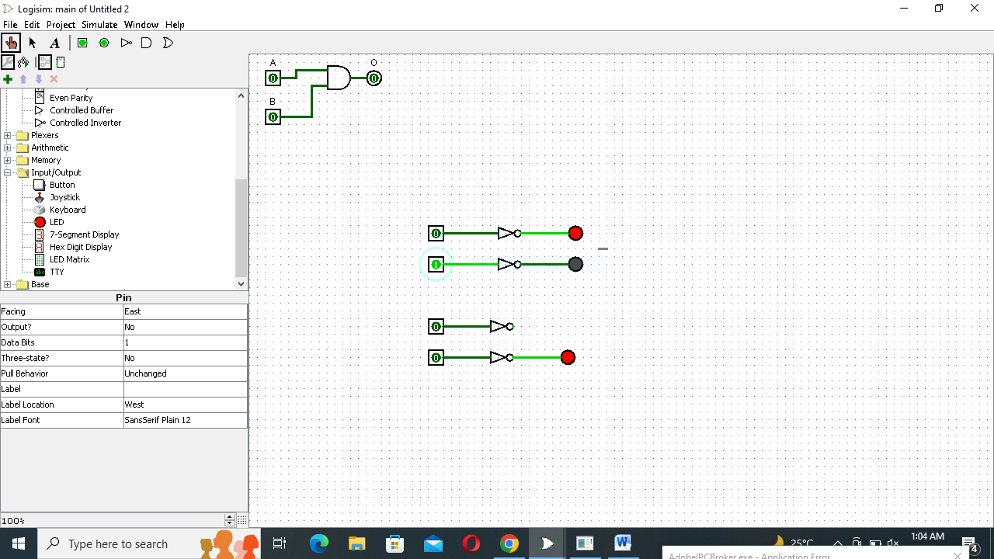

Q:2 Show how we can change/edit the properties of any device.

1. Go to "Devices" tab.
2. Click "All Managed Devices".
3. Select the Device you wish to modify.
4. Click "Edit -> Properties".
5. Change the "Property Refresh Policy" value to "Keep old values on rescan".
6. Now change the different fields as needed and click OK.

Q:3 Write down the functionality of Explorer Pane.

Logisim organizes tools into libraries. They are displayed as folders in the explorer pane; to access a library's components, you have only to double-click the corresponding folder. Some of these are the functionality of explorer pane.

* **Wiring:** Components that interact directly with wires.
* **Gates:** Components that perform simple logic functions.
* **Plexers:** More complex combinational components, like multiplexers and decoders.
* **Arithmetic:**  Components that perform arithmetic.
* **Memory:** Components that remember data, like flip-flops, registers, and RAM.
* **Input/Output:** Components that exist for the purpose of interacting with the user.
* **Base:** Tools that are integral to using Logisim, though you probably won't need to dig into this library very often.

Q:4 What do you think Logisim is good software for manipulating Digital circuits or not?

Yes, Logisim is a very good software for manipulating Digital Circuits because it is easy to learn and also very interesting.

THE END